DRAFT FOR DISCUSSION · SUBJECT TO CONTRACT · WITHOUT PREJUDICE

Keeping the Qualifying at Roehampton: a proposal to the All England Lawn Tennis Club
Surrender of the 2021 lease of the Sports Centre and Grounds and regrant of a lease of the playing fields, with an annual Qualifying operating arrangement, until the Qualifying Competition moves to Wimbledon Park. Prepared by Bruce Gillingham Pollard for the prospective purchaser of the estate. 17 October 2026.

1. The position today
- The Club holds a lease of the Sports Centre and Grounds granted by the Bank of England in June 2021; the lease plan excludes The Grange and the main car park. It runs to 2036 with a tenant break in 2031; the rent is £350,000 a year, stepping to £675,000 from 2031. It is outside the 1954 Act.
- The Club uses the estate for four days of Qualifying in late June on 18 grass courts, a main court with temporary stands for under 800 spectators, marquees, cabins and a public village, with up to about 2,000 spectators a day (a record 13,898 over four days in 2024). The site is closed to community sport from early May to the start of August for the build and breakdown. Marquees, grandstands and temporary facilities are consented for five years under 2025/4672, following 2024/0088 and 2022/1196.
- Outside the Qualifying the Club runs the Community Sports Centre: hard courts, grass practice courts in August and September, the sports hall and pitches, booked through Clubspark. The pool has been closed since 2020 and is the subject of a long-running local campaign (saveboe.org), which drew in two MPs, Sport England and the Public Accounts Committee.
- The Club's plans to move the Qualifying to the former Wimbledon Park golf course were approved by the Greater London Authority in November 2024. Save Wimbledon Park's judicial review failed in the High Court in July 2025 and the statutory trust claim was decided in the Club's favour in March 2026, with appeals threatened. The Club has said the new qualifying courts could be in use from 2029 once the grass has matured; a realistic planning case is 2029 to 2031.

2. What we propose
The purchaser takes a surrender of the 2021 lease on completion of its purchase and grants the Club a new lease of the playing fields, on terms that give the Club certainty for the Qualifying for as long as it needs Roehampton and a clean exit when Wimbledon Park is ready.
Demise | The grass courts and playing fields, the hard courts, the long-standing temporary pavilion at the north end of the Pavilion with its link and porch (about 4,780 sq ft), the Squash Courts building (3,233 sq ft) for player, official and storage use, and the groundsman's compound. The Sports Club, the Pavilion, car parks A and B, The Grange and the cottages are excluded.
Term | 10 years from the surrender, target 2028, with a tenant-only break on 12 months' notice exercisable at any time after the first Qualifying held at Wimbledon Park, and a landlord break if the Qualifying has not been held at Roehampton for two consecutive years.
Rent | £100,000 a year, fixed for the term, against the current £350,000 rising to £675,000.
Repair | The Club keeps the courts, fields, fences, temporary pavilion and squash building in repair and insures its own structures; the landlord insures the estate.
Event rights | Exclusive use of the fields for a Qualifying period of up to [12] weeks a year for build, event and breakdown, with the right to erect marquees, stands, cabins and temporary courts within the consents from time to time (currently 2025/4672 to 2031), which the Club keeps in force. Grass overflow parking on the fields as now.
Access | Both Bank Lane gates and the estate roads for the event, under an agreed traffic management plan; Gate 1 and the road west of The Grange for the fields year-round; up to [30] bays in car park A for officials during the event, Third Space keeping the rest.
Hospitality | An annual option, exercisable by 1 March, to hire the Pavilion function hall, bars and roof terrace from Third Space for the Qualifying period at a fee to be agreed in the Third Space lease, so the Club keeps hospitality in the historic clubhouse without holding the building for the other fifty weeks.
Community sport | The Club continues the Community Sports Centre programme on the hard courts, grass practice courts and fields outside the Qualifying period, which answers the local campaign and any renewed Asset of Community Value nomination.
Surrender | Surrender of the 2021 lease for no premium, each side bearing its own costs, conditional on the purchase completing; alternatively a deed of variation reducing the demise and rent to the same effect if the Club prefers to keep its 2021 title.

3. Why this works for the Club
- Certainty: a fixed, low rent and a term that outlasts any realistic delay at Wimbledon Park, with a break the Club controls.
- No stranded building: the Club gives up a 60,000 sq ft clubhouse and pool it does not use for fifty weeks of the year, and with it the repairing and holding cost, while keeping the temporary pavilion and squash courts it does use for the event.
- Hospitality on demand: the function hall and terrace come back for the fortnight each year under the Third Space option, fitted out and run as a members' club the rest of the time.
- A reopened pool: Third Space will refurbish and reopen the pool and sports hall as a members' club, which takes the pool question off the Club's desk and gives the local campaign the outcome it has sought since 2020.
- Community programme protected: the courts and fields stay in the Club's hands for the community programme until it leaves.

4. How the Qualifying would run each year
When | What happens | Who
By 1 March | Club confirms dates, the traffic plan, the car park A bay allocation and whether it takes the Pavilion hospitality option. | Club, landlord's managing agent, Third Space
Early May to mid June | Build on the fields: temporary courts, main court stands, cabins, marquees, village. Community sport on the fields pauses; Third Space trades as normal with 162 bays less the agreed allocation. | Club and contractors
Qualifying week, late June | Four days of play plus practice days. Spectators enter from Bank Lane under the traffic plan; grass overflow parking on the fields. Hospitality in the Pavilion if the option is taken. | Club
July | Breakdown and reinstatement of the fields; grass practice courts ready for community use from August. | Club
August to April | Community Sports Centre programme on the courts and fields; Third Space year-round in the buildings and pitch. | Club, Third Space

5. The plan
The plan below is the Club's 2021 lease plan from the data room registered onto the 2019 topographic survey. The new demise is in green, about 9.5 hectares against the 10.7 hectares surrendered; what comes out, the Sports Club, the permanent Pavilion and the 2G pitch, is in bordeaux. The Squash Courts are added to the Club's demise. The side column repeats the annual cycle in section 4.
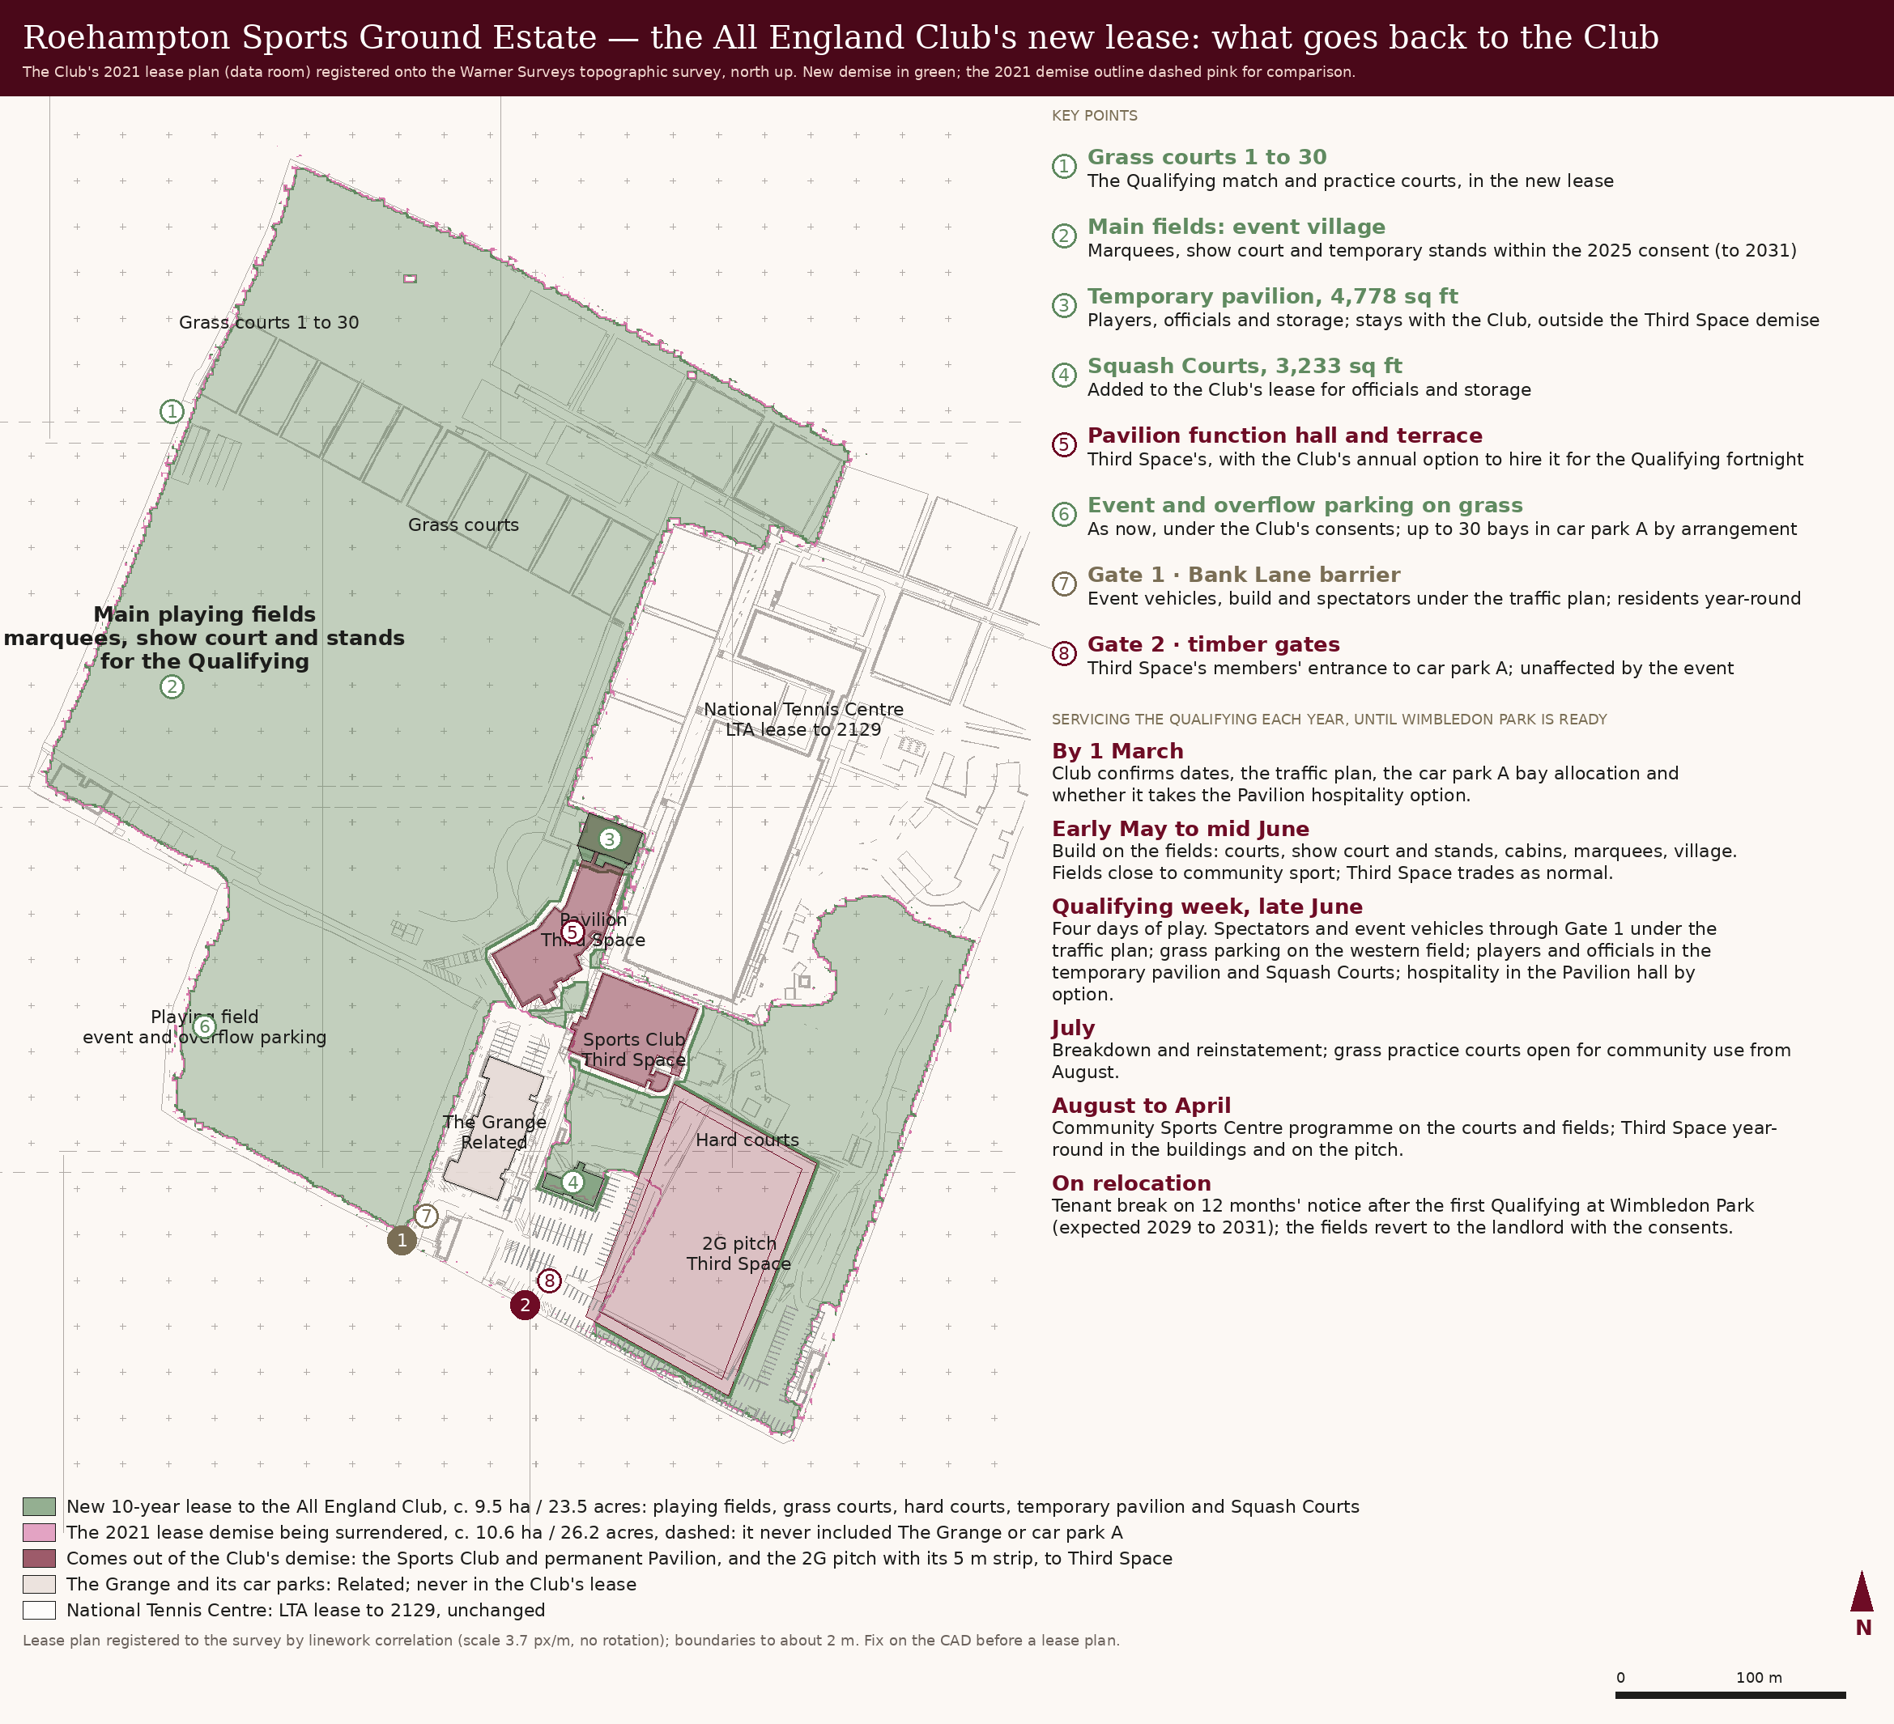

6. How the site is serviced for the Qualifying
- Courts and play: the grass courts in the north-west strip (1 to 30 on the 2021 plan) and the main fields for the show court, temporary stands and practice, as now. Nothing in the Third Space demise is needed for play.
- Players and officials: the temporary pavilion at the north end of the Pavilion (4,778 sq ft) and the Squash Courts (3,233 sq ft over two floors, the first floor for officials), both inside the Club's new lease, with cabins on the fields within the consent.
- Hospitality and media: the Pavilion function hall, bars and roof terrace under the annual option from Third Space, booked by 1 March; otherwise marquees on the fields as consented.
- Access: event vehicles, the build and spectators through Gate 1, the Bank Lane barrier, under the traffic plan, with the drive past The Grange and the road west of it to the fields; Third Space's members keep Gate 2 and car park A and are not affected.
- Parking: event parking on the western playing field as now, with up to 30 bays in car park A by arrangement with Third Space. Car park A was never in the Club's 2021 lease, so nothing changes there on the surrender.
- Services and welfare: the Club's existing cabins, toilets and power on the fields within the 2025 consent; water and power connections at the temporary pavilion kept on the surrender.
- Community sport: hard courts, grass practice courts and pitches outside the Qualifying period, booked as now.

7. Points to settle
- Whether the Club wants the Squash Courts building in its demise for player facilities, or would rather the landlord let it separately.
- The fee and mechanics for the Pavilion hospitality option, to be written into both leases.
- Renewal of the marquee and stands consent beyond 2031 if the move to Wimbledon Park slips; the Club carries this as it does today.
- The treatment of the Club's fixtures and fittings in the buildings on surrender, and the condition of the fields on the Club's eventual departure.
This proposal is made subject to contract and without prejudice, and is conditional on the purchaser exchanging contracts to buy the estate.

